Itai Carmeli Navigation Project
Contents
Introduction 1
The Problem 2
My Method 2
Assumptions 3
Estimating 4
Propagating (Short Term) 5
Final Estimation Results 6
Review of Results 9
Problem 1.1 - Potential Missions For This Orbit 9
Problem 1.2 – Data Gap Reasoning 10
Ground Station Data Gap Reasoning 10
GPS Data Gap Reasoning 12
Problem 1.3 – Operational Considerations 12
Problem 1.4 – Navigation and Control System 14
Problem 2 – Propagating 5 Hours 15
The Problems with Propagating a Long Time Ahead 15
UKF Propagation 15
Monte – Carlo Propagation 16
Uncertainty 16
Results 17
Future Work 18
Resources 18
Code 19

Introduction
This document presents my approach to analyzing, estimating, and propagating the orbit of a spacecraft using the measurement set provided by example data. The assignment focuses on two estimation methods, namely batch estimation and sequential filtering, and discusses the reliability of propagation with uncertainty.

The Problem
The primary task in this assignment is to analyze the orbit of a given satellite. Yet, before the orbit could be analyzed, it must first be estimated. To do this, there are batches of GPS measurements and batches of ground station measurements. These measurements come in different units and with their own noise covariance matrices. An optimal method for analyzing all this information is necessary to come up with the most accurate estimate of the orbit. Furthermore, it is necessary to come up with a measure of uncertainty regarding this estimate. Once that is completed, propagating the orbit ahead in time, without any further measurements, is required and, additionally, understanding the uncertainty of that propagation is necessary.

My Method
In order to be as coherent as possible, my algorithm for solving these problems was designed to be as modular as possible. Hence, the code (copied at the end) is “function” based and each part of the problem can be calculated separately. Furthermore, the code is designed to be universal, so that with only minor adjustments, other orbits with different assumptions given to me for the problem could also be analyzed.
To address the estimation aspect of the problem, two different filters were designed. One is a batch filter that was designed for the ground station readings, and the other is an extended sequential filter designed for the GPS measurements. The reasoning behind the use of each will be detailed in a later section.
As part of the filters, and for further use, a propagator needed to be built. Actually, four were built. The first propagator uses a state transition matrix inside the filters, so that the covariance matrix, in addition to the state, could also be propagated. A state transition matrix is designed using the dynamics of the problem, but as we shall see in our assumptions that this is presumed to be a two body Keplerian orbit, Goodyear’s Universal variable formulation could be used for the state transition matrix (Goodyear, 1969). For the second propagation, which is used for longer time intervals, the Runge Kutta 4th order method is used to differentiate the state dynamics of the satellite in orbit.
The third and fourth propagators were built with the question of a large time difference without measurements in mind. With a five hour difference between the last measurement and the desired propagation, the previous two methods would lead to high uncertainties and even singularities in their calculations. The state transition matrix is only good for short time intervals and the Runge Kutta method assumes linearization which would be inaccurate for longer orbits with pertubations. Hence, a statistical approach was taken to compute the final predicted orbit and its uncertainty. The unscented Kalman filter uses weighted sigma points around the initial state, propagates them using the linearized form, and then converges them into a final mean orbit and determine its uncertainty. The Monte Carlo propagator uses the same principle, only without weighted points and with a much higher number of points are propagated from the initial state. This last method takes up the most computational power, however a small sample was taken for this purpose.
After the orbit was reliably estimated, I performed an extensive analysis using several codes and visualization tools—such as orbit plots and elevation/azimuth assessments. Although these tools informed my understanding, my professional judgment and experience in orbital dynamics ultimately guided the interpretation of the results and the conclusions reached. Regardless of the outcome of the interview process, I would welcome any feedback on my analysis, as it would contribute meaningfully to my continued development as a GNC engineer.

Assumptions
Several simplifying assumptions were made due to the lack of environmental or hardware model data. The first assumption is that atmospheric drag is neglected. Initially it was as a first iteration assumption, but after propagating the orbit and seeing that the periapsis is roughly around 7300 [km], at an altitude of roughly 1000 [km] above Earth’s surface, it can be assumed that any atmospheric drag acting on the satellite at this altitude would be negligible.
The second assumption is that Earth is a perfect sphere. This is far from the truth and not irrelevant, as the spherical harmonics, most notably J2, have significant effects on satellites in orbit. Though the assignment mentioned to assume a spherical Earth, placeholders were created in the propagating code to allow for perturbations from other sources, including J2 and the other spherical harmonics.
Another one of those perturbations that was ignored, as an assumption, but could be added if necessary is the solar radiation pressure. The sun acting on the satellite could contribute to change in the orbital elements of the satellite, however since no surface area was given nor its reflective properties, and because this is one of the lower scaled perturbations acting on satellites, this was assumed as negligible as well.
The exclusion of third-body perturbations from other celestial bodies like the Moon and Sun is a more significant assumption to understand. While these bodies can introduce long-period variations in orbital elements, particularly for high-altitude missions, their influence is comparatively small for the orbit under consideration. Though this assumption is reasonable and consistent with the assignment scope, the propagator could nonetheless be extended to include these effects if required. As a consequence of limiting the problem to a two body Kepler orbit, the analytic two-body solution expressed through the Lagrange f and g coefficients could be used in the propagator. In the absence of perturbative forces, this formulation provides an exact description of the spacecraft’s motion and allows for efficient propagation over the time span of interest.
An additional assumption is that the state and measurement uncertainties are sufficiently small to justify local linearization. Both the batch estimator and the Extended Kalman Filter rely on linear approximations of the nonlinear dynamics, which remain valid only when deviations from the reference trajectory are limited. Given the quality of the measurements, and the relatively short propagation intervals, specifically from the ground stations, this assumption is appropriate for the present analysis, though alternative nonlinear filtering methods, such as the use of the UKF built for propagation, could be used.
To support the linearization process, a reference orbit is required. Because no reference orbit was given in the assignment, the first available GPS state vector was selected as the reference. This choice ensures consistency with the measurement set and provides an initial trajectory sufficiently close to the truth for linearization to remain valid. Other reference trajectories could be utilized if they were given.
Another thing to consider here is the idea that all the timestamps were seen as concrete. That is, they didn’t have uncertainties as well. This might be a reasonable assumption if the GPS and ground stations using atomic clocks, however, even atomic clocks have uncertainties. These uncertainties would be negligible in the scale of this orbit, however it is worth mentioning here.
It is important to note that the Earth is also not spinning, as detailed in the assignment. This is a relevant point when considering the ground stations and the times of their measurements as well as their lines of sight with the satellite.
Finally, the measurement uncertainties were treated as constant throughout the estimation process (for each ground station and the GPS), and no stochastic bias model was included. A more detailed characterization of the sensor errors would require knowledge of receiver performance, atmospheric conditions, and potential hardware biases, none of which were provided. Assuming a fixed covariance is therefore a reasonable simplification and adequately supports the batch and sequential filter formulations used.

Estimating
The process of estimating the orbit of the satellite relies on combining the available measurements into a coherent representation of the spacecraft’s trajectory. The estimation procedure for this assignment must consider the variations in measurement methods and units, as well as the varying time stamps of each batch of measurements. Taking into account the relatively high inaccuracy of the GPS measurements and the relatively long time between each measurement, then, a sequential filter was fitted to incorporate the given GPS data and provide an estimate based off it. The ground stations, though, provided much more closely spaced time measurements, and with a higher degree of accuracy. The challenge with these measurements, though, was that measurements only provided angles and their rates, without a measurement of distance. Therefore, only 4 variables were provided, which is not canonical to the six necessary to be solved for a full Keplerian orbit determination. Therefore, the ground station filters would have to use some sort of reference trajectory. To that end, the closest GPS measurement was used in a batch least squared filter that took the analytical conversation between Right Ascension and Declinaiton and their rates to provide position and velocity states in the ECI reference frame. Each method leverages the dynamics of a two-body Keplerian orbit and the associated measurement models to deliver orbital estimates while accounting for the limitations of the data.

Batch Least Squares Filter
The batch filter was applied to each of the ground station measurements to estimate the satellite’s orbit over the measurement interval. As mentioned, a key assumption in this method is that the closest available GPS measurement (in time) serves as the reference orbit for linearization. It is acknowledged that the initial offset from the true orbit could be substantial, particularly given the high eccentricity and altitude of the satellite, with particular consideration of the tru anomaly error (as the satellite moves fastest when it is close enough for ground measurements).
The batch filter algorithm operates by simultaneously considering all the measurements from the ground stations to produce a single, optimized estimate of the satellite’s orbit. Because there was only one small batch from each ground station that took a measurement every 30 seconds for 660 seconds, the window of operation was small enough so that no arcs needed to be created. For general purposes though, to mitigate potential linearization errors, batch filters implement a small-arc approach, wherein the State Transition Matrix (STM) propagates the covariance over shorter, more manageable intervals between observations. This approach ensures that the linear approximation remains valid, and allows for accurate computation of the correction to the reference trajectory. Though this approach was not necessary for the ground stations, a code (provided below) was written for the GPS measurements to do just that, but was not used.
After the State Transition Matrix propagates uncertainties between observations, an analytically derived matrix for conversation between the measurement units and the propagation units (from angles to positions and velocity) is used, and then a solution to a least-squares problem over the full measurement batch is implemented. The algorithm minimizes the overall discrepancy between the propagated state and the observations, adjusts the new reference trajectory for another iteration, and continues until a convergence is reached, resulting in a best-fit estimate of the orbit, in this case the orbit at the time of last GPS sighting relative to the ground station measurement, along with its associated covariance. This approach is particularly effective when the measurement set is dense and the linearization around the reference trajectory is valid, as it leverages all information at once to produce a statistically optimal solution.

Sequential Filter
The extended sequential filter algorithm, processes measurements one at a time, updating the state and covariance iteratively. This method is designed for real-time updating, as new information becomes available, and is less computationally invasive. It is also less prone to inaccuracies in estimations due to nonlinear dynamics and large time intervals, which is why it was chosen as the filter for the GPS measurements.
Starting from an initial reference state, which was taken to be the first GPS measurement, the algorithm predicts the satellite’s state forward in time using a propagator, in this case the use of the State Transition Matrix for Kepler’s universal variables, and then incorporates each measurement through a Kalman gain that balances the confidence in the prediction versus the measurement. This approach allows the filter to handle asynchronous or sparsely spaced data effectively, as it does not require reprocessing the entire dataset with each new measurement.
It is important to note that the long propagation times between GPS measurements can exacerbate linearization errors, making it crucial to employ robust propagation techniques, such as a carefully constructed STM, to maintain filter consistency and accuracy.

Propagating (Short Term)
An accurate propagator is necessary in this context not only for use inside the filters, but also for use in predicting where the satellite will be in the future. Hence, propagation involves computing the spacecraft’s trajectory based on the underlying two-body dynamics (while including the option to add higher-fidelity effects if desired). Luckily, the two-body problem can analytically be solved, and therefore a an accurate propagator can be designed, although the considerations for potential perturbations to be added in were considered in its design. In this assignment, propagation was performed using a combination of analytic and numerical methods, chosen based on the interval of propagation and the required precision. Short-term propagation benefits from linearized models and State Transition Matrices. Longer-term propagation, especially for periods of several hours beyond the last measurement, requires more robust numerical integration due to the increasing effects of nonlinearities in the orbital motion and will be discussed in a later section. The goal of these propagation steps is not only to estimate the position and velocity of the satellite but also to provide a consistent evolution of the covariance matrix, which captures the growth of uncertainty over time.

Universal Variables and State Transition Matrix
For short-term propagation within the estimation filters, the State Transition Matrix (STM) approach was implemented. The STM provides a linear mapping from the deviation of the state at the reference time to the deviation at a future time, allowing the covariance to be propagated analytically alongside the state. Calculating the STM for a system is no easy task when dealing with multiple perturbations. However because of our assumption of two body dynamics, it is possible to use Goodyear’s Universal Variable formulation.
Goodyear’s Universal Variable formulation is an analytic method for propagating the position and velocity of a spacecraft along a Keplerian orbit, applicable to all conic sections, including elliptical, parabolic, and hyperbolic trajectories. The core idea is to express the motion in terms of a single universal anomaly, which generalizes the eccentric and hyperbolic anomalies used in classical orbital mechanics. By introducing this universal anomaly, the formulation transforms the two-body problem into a set of algebraic equations that can be solved efficiently for a given time interval. The position and velocity at any future time are then obtained using Lagrange’s f and g coefficients, which relate the initial state to the propagated state through closed-form expressions.
Once calculated, the STM provides a linear mapping from the deviation of the state at the reference time to the deviation at a future time, allowing the covariance to be propagated analytically alongside the state. The algorithm begins by defining a reference orbit, in this case taken from the first GPS measurement, and computing the nominal position and velocity. Within the batch and sequential filters, the STM enables efficient updating of both the predicted state and its uncertainty between measurements, ensuring that linearization errors remain minimal for short arcs of the orbit.

Runge Kutta
For numerical propagation over longer intervals, the fourth-order Runge Kutta method is a popular and accurate one. Unlike the STM, which relies on linearization around a reference orbit, Runge Kutta numerically solves the differential equations of motion directly, providing higher fidelity for nonlinear dynamics. In the algorithm, the satellite’s position and velocity at the start of the interval are integrated forward in small time steps, with intermediate evaluations of acceleration and velocity used to compute an accurate state at the end of the propagation period. This method is particularly useful when the propagation interval is long enough that linearization errors would accumulate significantly, such as for highly eccentric orbits like the one under consideration, and when the perturbations on the system are myriad. While this method is accurate for large time intervals, it does not provide a method of propagating the uncertainty of the state. Hence, this propagator was used only for the purpose of plotting a whole period of orbit.

Final Estimation Results
After acquiring an estimate based off each ground station and the GPS measurements, a fusion of these estimates was made, once again, using the extended sequential filter. Each estimate had its own covariance at its own particular time. Hence, it was necessary to propagate these estimates to the appropriate time and fuse them together to come out with one final estimation of the orbit and its uncertainty.

Plots
Once a final estimate of the orbital parameters was made, the whole orbit could be propagated and plotted. A basic plot of the orbit can be seen here:
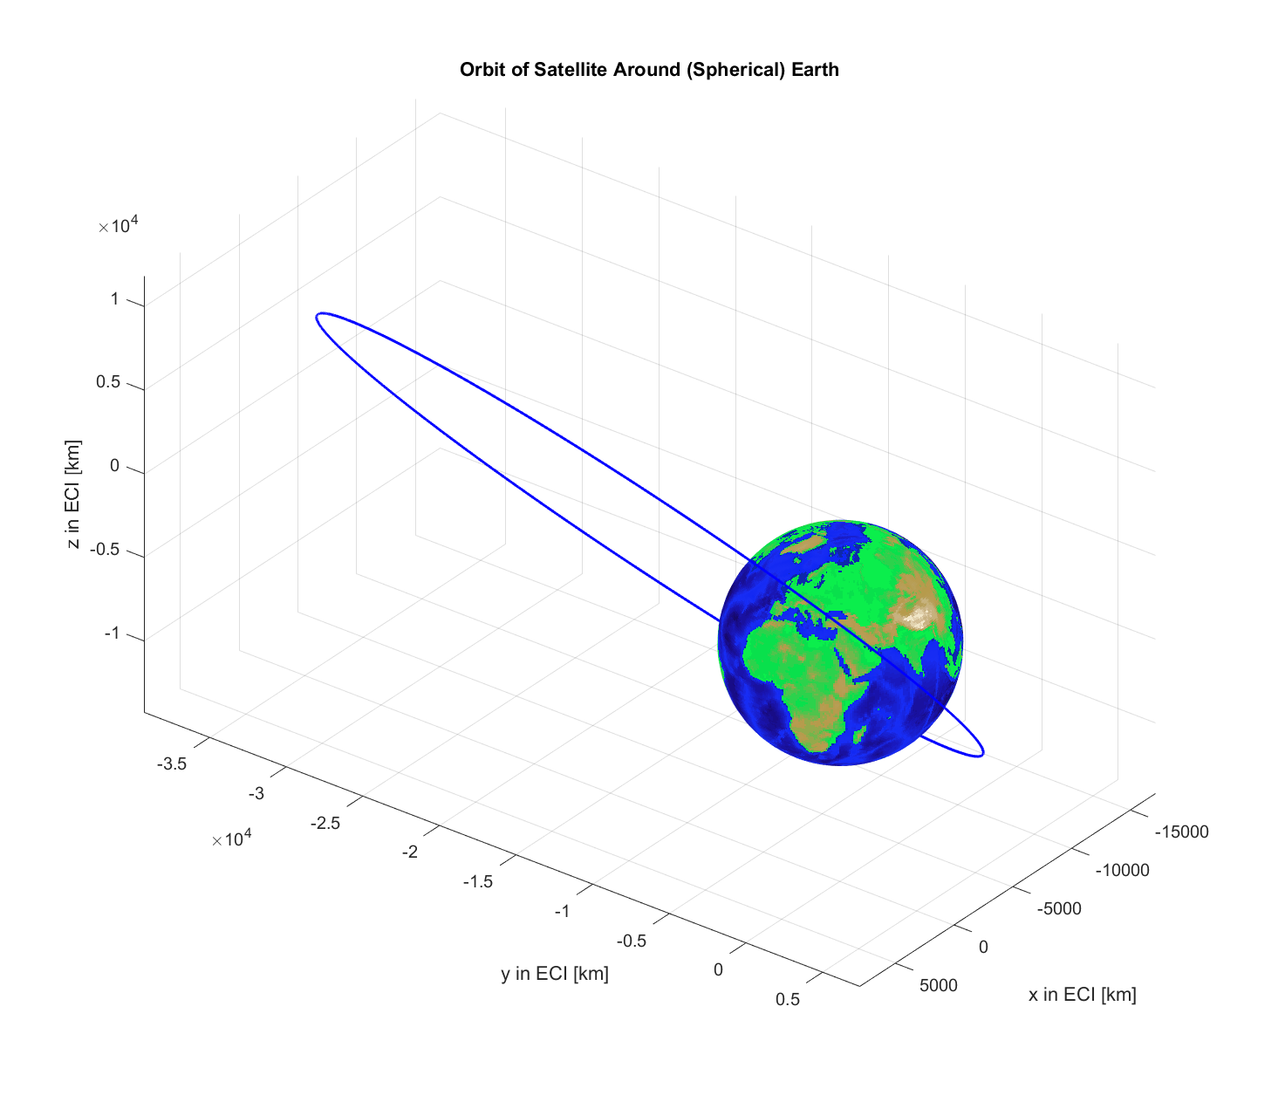
It is noticeable how eccentric the orbit is from this plot. For further analysis, the plot was expanded to include the ground stations, their respective lines of sight, and the uncertainty ellipsoid of the fused measurements (one for each ground station and the GPS measurements). This plot is shown here:
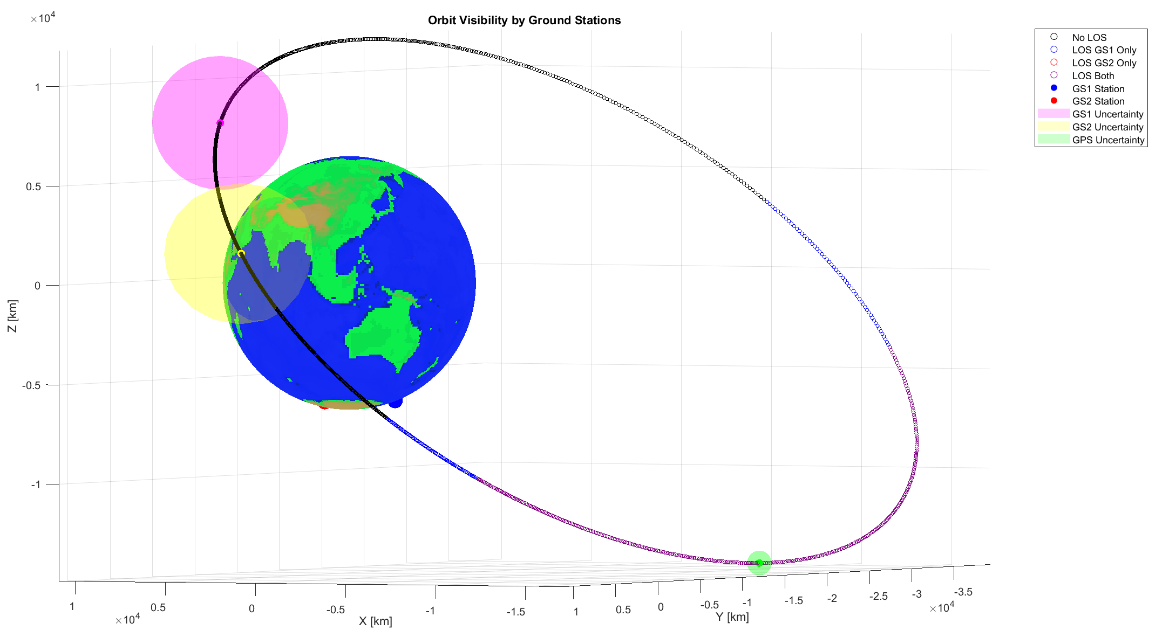
An important thing to note is that from this image, the fused states of the ground station estimations seem not to be in line of sight from this image. Remember, these estimations are set to the reference trajectory of the closest GPS measurement, which came before the measurements from the ground station. This means that there is some propagation time, about 5 minutes for each measurement batch, before the ground station measurement was taken.

Orbital Elements
Our final fused states were calculated using position and velocity states, however, for convenience, they have been converted to Orbital Keplerian Elements. The tru anomaly is not given here because it is the element that changes rapidly throughout the orbit, so it has been omitted.
$${\hat{x}}_{fused}=\left[\begin{aligned}\hat{a} \\ \hat{e} \\ \hat{i} \\ \hat{Ω} \\ \hat{ω}\end{aligned}\right]=\left[\begin{aligned}23974 \left[km\right] \\ 0.693 \\ 48.6° \\ 258° \\ 174°\end{aligned}\right]$$

Covariance
Since the state was propagated in the position and velocity space, the covariance matrix was also calculated such. However, it is possible to convert the covariance matrix into the orbital elements unit, for the sake of intuition, using the Jacobian matrix, which can be derived analytically or numerically. A numerical function was used to calculate the Jacobian. The covariance matrix in position and velocity states as well as orbital element states are provided here:
$$P_{rv}=\left[\begin{matrix}356169 [m^{2}] & 0 & 0 & 35.64 & 0 & 0 \\ 0 & 344951[m^{2}] & 0 & 0 & 35.23 & 0 \\ 0 & 0 & 355982[m^{2}] & 0 & 0 & 35.62 \\ 35.64 & 0 & 0 & 0.00696 \left[\frac{m^{2}}{s^{2}}\right] & 0 & 0 \\ 0 & 35.23 & 0 & 0 & 0.00695\left[\frac{m^{2}}{s^{2}}\right] & 0 \\ 0 & 0 & 35.62 & 0 & 0 & 0.00696\left[\frac{m^{2}}{s^{2}}\right]\end{matrix}\right]$$
Again, the tru anomaly is not represented here because bears no relevance to the overall orbit since it throughout the orbit.
$$P_{oe}=\left[\begin{matrix}2783 \left[km^{2}\right] & & & & \\ & 2.105x{10}^{-10} & & & \\ & & 1.64x{10}^{-6}[\deg^{2}{]} & & \\ & & & 2.84x{10}^{-6}\left[\deg^{2}\right] & \\ & & & & 4.27x{10}^{-5}\left[\deg^{2}\right]\end{matrix}\right]$$
Because we used a numerically computed Jacobian, and because the covariance between the different orbital elements are not pertinent to understand the scope of the uncertainty, the Variances of the orbital elements were presented.

Review of Results
The final estimated orbit and its uncertainty provide a good picture for the state of the satellite. It can be seen that the ground measurements have higher uncertainty than the GPS measurements, which can be expected as there were only 4 variables that the measurements provided as opposed to the six needed to calculate an orbit. It can also be seen that the estimated orbit at $t_{f}=12000 [sec]$ is very close to the final orbit measured by the GPS. This is logical as the high relative uncertainty by the ground station, and long time it needed to propagate to $t_{f}$ would mean that the fused estimate would have given more weight to the GPS measurements. We can see that the final orbital element parameters and its uncertainty are within understandable ranges as well.

Problem 1.1 - Potential Missions For This Orbit
There are several things to consider when analyzing this orbit. The first thing one notices about the orbit is its highly elliptical shape. Secondly, the relatively large semi major axis. The combination of these two numbers yields several conclusions for the potential mission that would be suited for this type of orbit.
In accordance with Kepler’s Second Law, a highly eccentric orbit would spend more time around the apogee, estimated to be 40578 [km], than the perigee, as it is moving slower there. It’s moving the fastest at the perigee, which is estimated to be at 7371 [km]. This means that the satellite coverage is very fast on the perigee, and long on the apogee. This suggests that the mission would be designed for maximum coverage time around the apogee.
Yet the high semi major axis is helpful in understanding the limitations of what it can do with that coverage. The long apogee means it would be inefficient to have optical payloads pointing towards earth. However, the farther the satellite is from Earth allows for interesting measurements of deep space, although this would be a rare mission.
The main idea of this mission is concentrated coverage. The type of mission would include reliable satellite communication that is available for long periods. Specifically, the high inclination in conjunction with the near 180 [deg] argument of periapsis suggests that this coverage is designed over a specific part of the southern hemisphere. This can be verified by looking at the large percentage of the orbit that is covered by both ground stations which are stationed in the southern hemisphere.
The right angle of ascending node would dictate the longitude of where in the southern hemisphere this converge is concentrated. If we take into consideration that the Earth isn’t spinning in this model, then coincidently this aligns off the western coast of South America. At the apogee, the point of maximum coverage (yet maximum distance), the latitude is somewhere at -4 degrees.
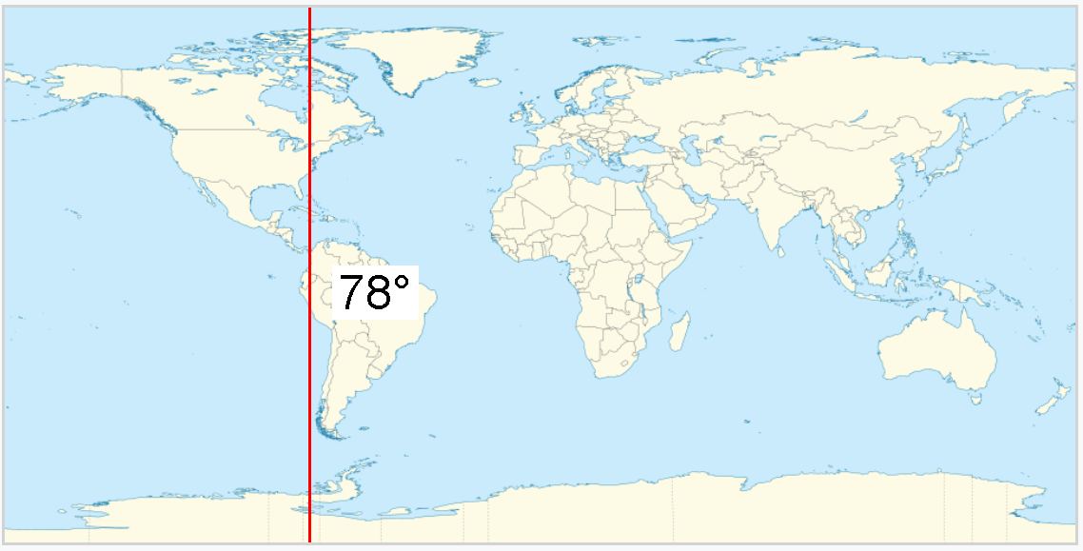

Problem 1.2 – Data Gap Reasoning

Ground Station Data Gap Reasoning
Let’s start with the ground stations. There are several factors that could lead the observations to be intermittent. First is the geography of the antenna. If there is a mountain or structure obstructing its line of sight with the satellite, it could hinder the readings from the ground stations. Secondly, there could be an issue with the avionics of the satellite itself; some electrical malfunction or antenna direction offset that isn’t being accounted for. Weather could also play a role in how a ground station operates, affecting power at the station or its ability to receive measurements.
Other than these issues, which could be for any orbit and any ground station, there are two main considerations to take into account when trying to understand the intermittent ground station measurements, and that is line of sight and range. Line of sight could be obstructed from a structure, sure, but it can also be done so by Earth itself. If the satellite is positioned so that the elevation from the ground station is below the horizon, then there wouldn’t be a signal from the satellite. Hence, elevation is something being considered, as seen in the Azimuth-Elevation plots below for each ground station:

The solid line represents the visible part of the propagated orbit from the fused estimate at each ground station. This shows a limited time window to see the satellite, but it also shows that the satellite has a line of sight at more points than it has measurements for.
In comes range. Satellite and ground station communication is not all powerful. A satellite must consider the electrical power it provides for various aspects of its mission, whether it be attitude determination and control, payload operation, uplinking and downlinking data, or ground navigation. Their power budget directly corresponds to the strength of the signal that the satellite can send to the ground stations. The further the satellite is, the more powerful the signal it sends needs to be in order to reach the ground station. Hence, an interpretation of the ranges from the ground station to the satellite should be done:
time [sec] | GS 1 Range [km]
5130 | 2604
5160 | 2850
5190 | 3098
5220 | 3347
5250 | 3597
5280 | 3849
5310 | 4102
5340 | 4357
5370 | 4613
5400 | 4871
5430 | 5129
5460 | 5389
5490 | 5650
5520 | 5913
5550 | 6176
5580 | 6440
5610 | 6705
5640 | 6971
5670 | 7237
5700 | 7505
5730 | 7772
5760 | 8040
5790 | 8308
time [sec] | GS 2 Range [km]
6510 | 4808
6570 | 5354
6630 | 5893
6690 | 6425
6750 | 6948
6810 | 7463
6870 | 7969
6930 | 8466
6990 | 8955
7050 | 9435
7110 | 9906
7170 | 10369
It can clearly be seen that the ranges increase at the end of the measurements in both stations to roughly 10000 [km]. This is roughly 10 times higher than most LEO satellites. That is far, and highly likely that the signal power was too weak for the ground station to read.

GPS Data Gap Reasoning
time [sec] | Range from Earth [km]
0 | 26604
600 | 25041
1200 | 23364
1800 | 21564
2400 | 19634
3000 | 17569
3600 | 15370
4200 | 13062
4800 | 10729
5400 | 8634
6000 | 7428
6600 | 7860
7200 | 9621
7800 | 11887
8400 | 14225
9000 | 16484
9600 | 18617
10200 | 20614
10800 | 22478
11400 | 24216
12000 | 25835
GPS works by triangulating a receiver’s position with at least four satellites of the GNSS system (or other GPS constellations). These satellites are positioned around MEO orbits, with a semi major axis of around 26000 [km] and an eccentricity that is nearly circular. These GPS constellations are expected to provide navigation for receivers on earth, and so that is where their antennas are pointing. Beyond their orbit, they will not be able to triangulate position and velocity vectors. This is the basis for the gaps in the GPS data.
We can see that the range of the GPS measurements start with the first measurement at roughly the same range as the GNSS constellation. That is when the satellite was first able to be acquired by GPS after spending time in the deeper space part of its orbit. The GPS data is consistent until it reaches the part of the orbit that is leaving into deeper space once again. After its final measurement, the satellite is in the part of the orbit beyond the GPS constellation, and hence won’t be able to receive measurements until it returns “inside” the zone.
It is worth noting that the closer the satellite gets to the GNSS constellation orbit, the less accurate the GDOP, or geometric dilution of precision, becomes. Triangulation becomes inefficient at these altitudes, and so it is worth considering when taking into account the noise variance of the GPS measurements.

Problem 1.3 – Operational Considerations
There are a few GNC aspects that would come into consideration if we didn’t consider our assumptions. Drag and third body perturbations, specifically J2 perturbations, would affect this highly eccentric orbit, and if the goal was to have a large coverage time over a specific area, it would be necessary to implement some kind of orbit control. However, our assumptions of two body dynamics and no perturbations with a non-rotating and a spherical Earth means that orbital guidance would be less of a burdensome on the propulsion design. If these assumptions weren’t part of the scenario, then orbital maintenance would need to counteract, most prominently, the effects of the spherical harmonics, third body perturbations from the moon if it is close at the apogee, and solar radiation pressure acting on the satellite. These effects might be small for a highly energetic orbit such as this, but the drift they garner could accumulate to compromise the mission parameters. Hence, orbital corrections would be down at incremental times. The tolerances of these drifts should be based on the mission and the fuel budget on the satellite.
When it comes to power generation, it would be prudent to consider the sun vector from the satellite throughout the year and see when the earth would be blocking it. Averaging out the year, the satellite will most likely have a clear line of sight to the sun when it is at the further part, when it is at its highest incline and far away from the Earth. It would be prudent to create a solar charging algorithm that uses this time to charge the satellite’s power system via its solar arrays.
As previously shown, it is difficult to send a signal the further the satellite is. Hence, it would be advantageous to communicate with earth when it is closest to the satellite, around the perigee. The issue here is that there isn’t much time for a single ground station to remain in range of the satellite as it travels its quickest part of the orbit, as seen earlier. Hence, a network of ground stations, and patched downlinking algorithms would need to be constructed so that communication with the satellite is as seamless as possible.
Of course, it is necessary to have an attitude control system that can implement all this. Because the ground tracking at the perigee is so fast, and because antenna on the satellite needs to be pointing in the right direction, a highly responsive and highly robust attitude controller must be implemented. A very sensitive and yet very accurate attitude determination and control system is necessary for the avionics to work correctly at the perigee. This means redundant star trackers and IMU’s, robust reaction wheel configurations and a quick and easily powered motor. This same system needs to be used later in orbit to continue sun pointing and payload operation.
It is important to note that the attitude control system would also be in charge of dumping extra momentum. Because the altitude of the satellite is so high for the entirety of the orbit, it does not make sense to have any magnetorquers on the satellite, as the magnetic field strength dissipates further from Earth. Therefore, the satellite must be able to change total angular momentum with reaction control system (RCS) and must be able to do so on all axes. This has significant implications for the design of the spacecraft, specifically its mass and its lifespan, as there is only so much fuel that the satellite can hold.
As the spacecraft moves from perigee, where Earth’s infrared heating and reflected sunlight are strongest, to the much colder, more distant apogee, its thermal environment can swing dramatically, requiring a robust mix of passive and active control. Radiators and multilayer insulation must be sized to handle long cold periods at high altitude, while heaters prevent critical components from dropping below operational temperatures during extended eclipses, which are common in eccentric orbits. Conversely, near perigee, the spacecraft may experience intense heating and rapid transitions in thermal load that can induce thermal stress in structures and instruments. The varying attitude needed for communication or payload operations may also expose different surfaces to sunlight, complicating thermal balance. As a result, the thermal control subsystem must be designed to maintain component temperatures across a wide and rapidly changing thermal environment, ensuring stability and reliability throughout the orbit.
As the satellite travels through this estimated orbit, it is expected to go through the outer Van Allen radiation belt, where energetic electrons and protons can degrade electronics, damage solar panels, and hinder communications. The satellite’s high inclination further increases exposure to regions like the South Atlantic Anomaly, where trapped particle fluxes are elevated. At apogee, reduced geomagnetic shielding allows more cosmic rays and solar energetic particles to reach the spacecraft, especially during periods of heightened solar activity. Radiation effects also influence lifetime predictions, battery degradation, sensor noise, and dosimetry monitoring, making radiation protection a critical element of mission operations and system reliability. These combined effects require robust radiation-hardened electronics, shielding optimized for mass constraints, careful placement of sensitive components, and fault-tolerant software strategies that allow for redundancies.

Problem 1.4 – Navigation and Control System
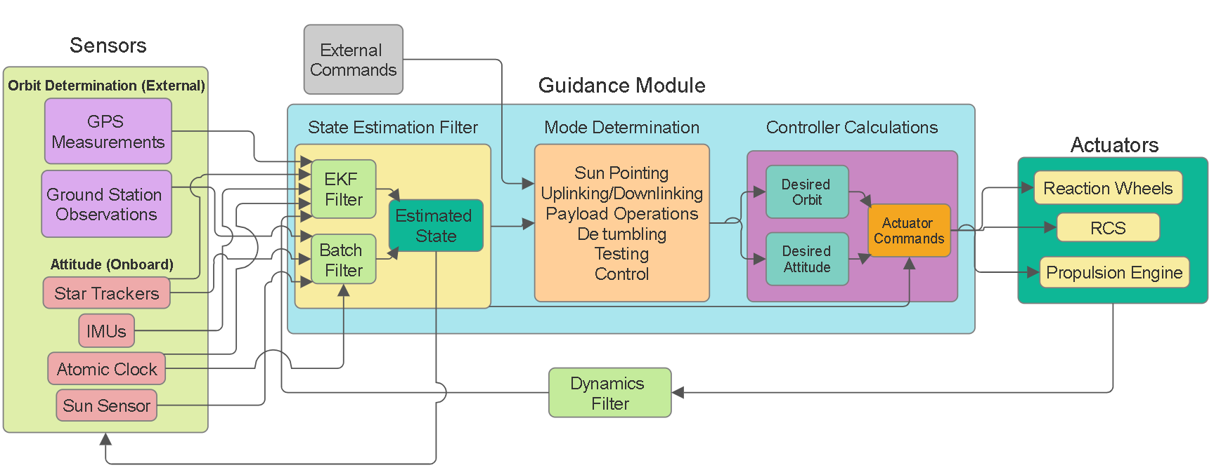
The above figure describes the navigation and control system designed to handle the operational challenges of this orbit. It takes in information from sensors on the satellite (that measure the satellite’s attitude) and off the satellite (that measure the satellite's orbit). After running these measurements through their respected filters, based on measurement time intervals and linearity of the state space model, the estimated state is created. This state is made up of both the orbit and the attitude, and it is fed into the Guidance Module to determine the operational mode of the satellite. It is important to understand that the operational mode is determined by considering both the orbit and the attitude. Where the satellite is in orbit will have an effect on the mode being determined as well as the attitude of the satellite. External commands, shown in the grey diagram, can come from overriding commands sent from mission control, or from the satellite BUS (such as low power mode, etc....). The mission mode, using the inputted estimated state ,will give out the desired orbit and desired attitude to correct for, and then actuator commands would calculate how to control those desired states from the current estimated state. Those commands are then relayed to the actuators.
For our specific orbit, the speed at which the attitude estimation and control system enacts its commands must be considered. That means that the actuator commands/controller must be rapidly converging. It may be considered to have overshoot in certain situations for the sake of faster convergence.
Furthermore, the sensors themselves need to be controlled, as there are certain avionics/power considerations to consider. It would not be wise to power up the high band antenna for ground stations when they are not in range or in a line of sight. Hence the sensors should receive the estimated state as a calculation of when to turn them on or not.

Problem 2 – Propagating 5 Hours

The Problems with Propagating a Long Time Ahead
When propagating a spacecraft’s state far into the future, several challenges arise that reduce the reliability of the predicted trajectory. Over long-time spans, orbital dynamics become increasingly nonlinear as small perturbations (from sources discussed before - atmospheric drag, Earth’s oblateness, solar radiation pressure, and third-body effects) accumulate to effect the overall propagation. Although the current model assumes pure two-body motion, which greatly simplifies the dynamics to be analytical, orbital motion deviates from this idealized case the farther ahead we propagate. As a result, the State Transition Matrix , which assumes locally linear behavior around the reference trajectory, becomes progressively less accurate with time. The STM captures how small variations grow or shrink, but its linear approximation breaks down as nonlinear effects dominate, causing the predicted covariance and state estimates to drift away from the truth.
Though there are many ways one could use to propagate an orbit, a demonstration of the powerful nonlinear estimation tools will be shown here, the Unscented Kalman Filter (UKF) and Monte Carlo simulation. The UKF leverages the unscented transform to propagate a carefully chosen set of sigma points through the full nonlinear dynamics, capturing mean and covariance evolution more accurately than linearization-based methods like the EKF. This makes it well-suited for long-duration scenarios where nonlinear effects accumulate. Monte Carlo simulation offers an even more general approach by numerically propagating a large ensemble of randomly sampled initial states, allowing the analyst to observe the full distribution of outcomes rather than just the first two moments. While computationally more expensive, Monte Carlo provides a benchmark for assessing long-term uncertainty growth. Together, these methods provide robust frameworks for analyzing how nonlinear orbital dynamics and environmental perturbations impact spacecraft trajectory predictions over extended time horizons.

UKF Propagation
The novelty of the UKF lies in its use of the unscented transform to accurately propagate the mean and covariance through nonlinear dynamics without requiring linearization. By using carefully chosen sigma points, it captures higher-order moments of the state distribution that the EKF would miss. For the 5 hour propagation, the fused (GPS and ground station measurements) position and velocity estimates, which is set at $t_{f}=12000 [sec]$, and the covariance matrix for that point were used as inputs for the UKF. The resulting orbit, in both position and velocity states and orbital elements states is described:
$${\hat{x}}_{ukf_{t_{f}+5h}}=\left[\begin{aligned}-4480 [km] \\ -37633 [km] \\ 4056 [km] \\ 1.348 \left[\frac{km}{s}\right] \\ 0.920 \left[\frac{km}{s}\right] \\ 1.275 \left[\frac{km}{s}\right]\end{aligned}\right] {\hat{oe}}_{ukf_{t_{f}+5h}}=\left[\begin{aligned}\hat{a} \\ \hat{e} \\ \hat{i} \\ \hat{Ω} \\ \hat{ω} \\ \hat{ν}\end{aligned}\right]\left[\begin{aligned}23975 [km] \\ 0.69 \\ 48.61° \\ 257.8° \\ 174.4° \\ 193.8°\end{aligned}\right]$$

Monte – Carlo Propagation
Simply put, Monte Carlo simulations propagate a large number of randomly sampled states. It then analyzes the final propagation of those states to capture the full statistical distribution of a system’s behavior. Though they are more heavily computational (the more iterations, the higher the accuracy but also the more computer power and time it takes to calculate all of these propagations), they are particularly useful for nonlinear dynamics, as they do not rely on linearization assumptions. This approach provides a direct way to estimate uncertainties and visualize the spread of possible outcomes. The resulting orbit of a 100 case simulation, initiated at our fused state, is:

$${\hat{x}}_{{mc}_{t_{f}+5h}}=\left[\begin{aligned}-4480 [km] \\ -37633 [km] \\ 4056 [km] \\ 1.348 \left[\frac{km}{s}\right] \\ 0.920 \left[\frac{km}{s}\right] \\ 1.275 \left[\frac{km}{s}\right]\end{aligned}\right] {\hat{oe}}_{{mc}_{t_{f}+5h}}=\left[\begin{aligned}\hat{a} \\ \hat{e} \\ \hat{i} \\ \hat{Ω} \\ \hat{ω} \\ \hat{ν}\end{aligned}\right]\left[\begin{aligned}23975 [km] \\ 0.69 \\ 48.61° \\ 257.8° \\ 174.4° \\ 193.76°\end{aligned}\right]$$

Uncertainty
In the given problem, the main way to determine the uncertainty of a propagation is through the covariance matrix. When using filters, it is applicable to use the Residual Mean of Squares, but because a propagation has no measurements, then the only method of determining how uncertain an estimated future state is through the covariance matrix. This matrix, in both the UKF and Monte Carlo method, is computed using the distribution of final states that were propagated from the initial mean and orbit and using the initial covariance matrix. The matrixes for both methods are shown here for the position and velocity state (no Jacobian is calculated). Because they are symmetric, only one half of the matrix is written:
$$P_{ukf}=\left[\begin{matrix}6715742 \left[m^{2}\right] & & & & & \\ 11992343 & 25006537 \left[m^{2}\right] & & & & \\ 3802839 & 746786 & 3119026 \left[m^{2}\right] & & & \\ 375 & 805 & 244 & 0.03 \left[\frac{m^{2}}{s^{2}}\right] & & \\ 1475 & 2998 & 912 & 0.1 & 0.36\left[\frac{m^{2}}{s^{2}}\right] & \\ 84 & 170 & 33 & 0 & 0.02 & 0\end{matrix}\right]$$
$$P_{mc}=\left[\begin{matrix}6102349 \left[m^{2}\right] & & & & & \\ 10655518 & 22426271 \left[m^{2}\right] & & & & \\ 2981406 & 5772489 & 2220939 \left[m^{2}\right] & & & \\ 349 & 753 & 199 & 0.03 \left[\frac{m^{2}}{s^{2}}\right] & & \\ 1302 & 2655 & 699 & 0.09 & 0.32\left[\frac{m^{2}}{s^{2}}\right] & \\ 78 & 172 & 28 & 0.01 & 0.02 & 0\end{matrix}\right]$$

Results
It is clear that in both methods, the propagated orbit is identical to the original orbit. This is to be expected for a two body orbit! That is, the propagation of an unperturbed orbit of a satellite is analytical, and so the errors accumulated over time through the propagation are nonexistent. Only when perturbations are included would we expect to see a difference between the initial orbit, and the propagated orbit.
The covariance matrix, however, is not the same for each case. This is also to be expected, since the Monte Carlo simulation took 100 randomly chosen initial points, while the UKF had carefully selected sigma points to propagate. If another MC simulation was to be run a different covariance matrix would be calculated, because there would be a new distribution of points. If the UKF was to run again, the same covariance matrix would be shown, since the same points with the same uncertainty (standard deviations away from the mean) would be propagated.
We can visualize the propagated orbit and the uncertainty from each method such that:
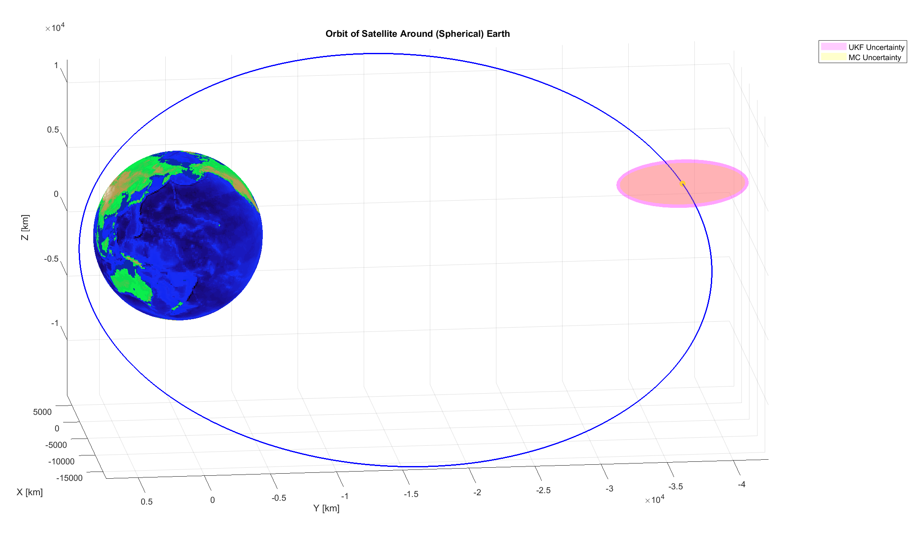
The propagated mean of the points after five hours is seen to be identical, near the apogee, but the slightest difference in the uncertainty can be seen on the ellipsoid between the UKF and the Monte Carlo simulation.

Future Work
- Use a UKF with measurement updates
- Find a method other than STM to propagate both the state and the uncertainty (differential algebra, square root ukf)
- Add controller for the orbit using
- Add perturbations (solar radiation pressure, moon, j2…)

Resources
Goodyear, R. L. (1969). A Method for Computing Satellite Predictions. NASA.

Code

